Guide for submitting your thesis

Please, read this document before submission!

Only those students who registered for the final exam in Neptun system till the deadline can submit their thesis. Students who missed the final exam registration deadline but would like to take the final exam have to submit a request in Neptun system (Administration> Requests) and pay in the registration fee.
Students can request the extension of the thesis sumbission deadline. The request shall be submitted in Neptun system (Administration>Requests) and a registration fee shall be paid.

Students are obliged to submit one full pdf copy of their thesis! Only pdf formats are allowed to be uploaded!
Parts of thesis to be submitted: the cover page, table of contents, the whole text with images, figures, appendices, works cited and the completed and signed authentication declaration on the last page.
The authentication declaration shall be signed in blue ink and the scanned version shall be placed as the very last page of the thesis. Then the thesis shall be uploaded to the relevant system.
The declaration is available here
Formal requirements of the thesis is stipulated by Section 51§ of Code for Studies and Exams in the Academic Regulations for Students. These are also stipulated by the Dean’s regulation at the relevant faculty.
In view of the current epidemic situation, theses shall only be uploaded to Neptun. No printed version shall be submitted at the relevant departments
Only the following file name format is possible: the author’s name in capital letters_year of submission. The extension shall be PDF (e.g. ABCDEF_2020.pdf). The file shall not be secured.
Thesis submission is rejected if:
• the submission sheet is completed in capitals only (e.g. the title of the thesis is in capitals only)
• obligatory sections are not completed
• the file of the thesis is not appropriate
• the name of the file is not appropriate
• the authentication declaration is not completed and signed or is not included in the thesis"

Uploading the thesis:
The electronic version of the thesis shall be uploaded to Neptun as follows:
Click on „Studies” and „Thesis application”.

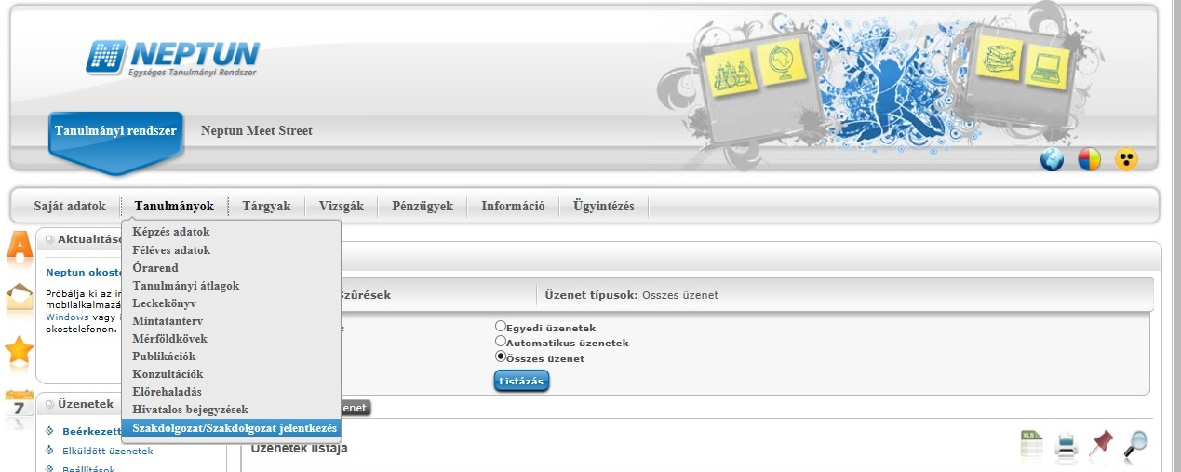

Then click on „Uploading thesis”.

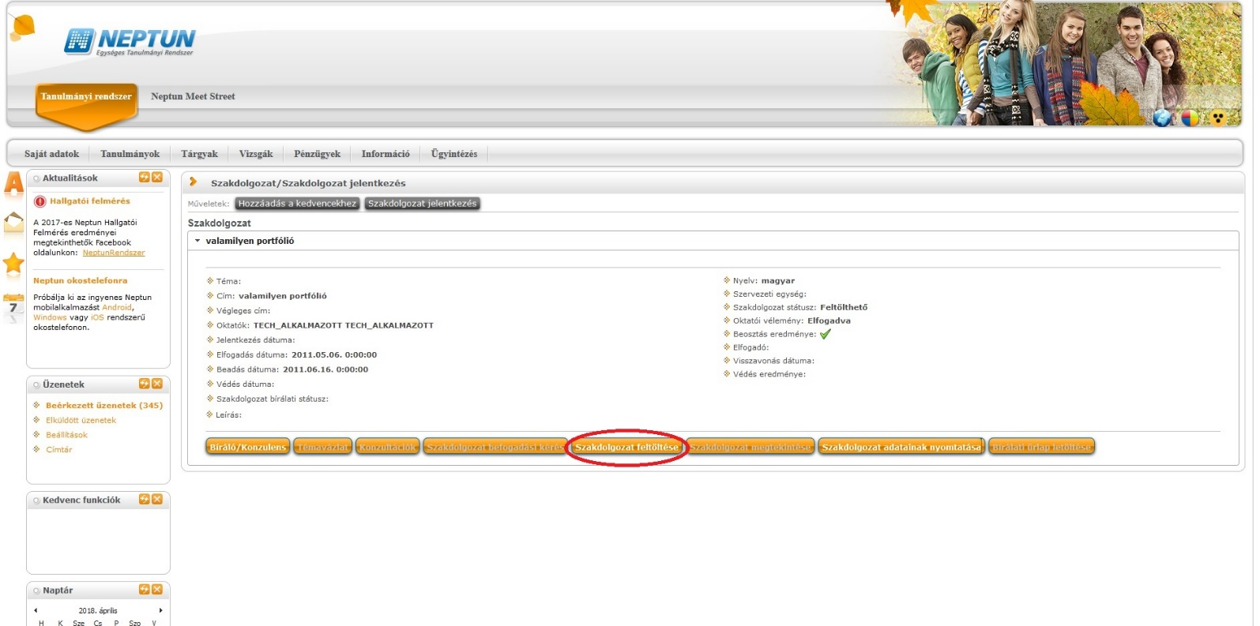

Then give the final name of your thesis and click on „continue”.

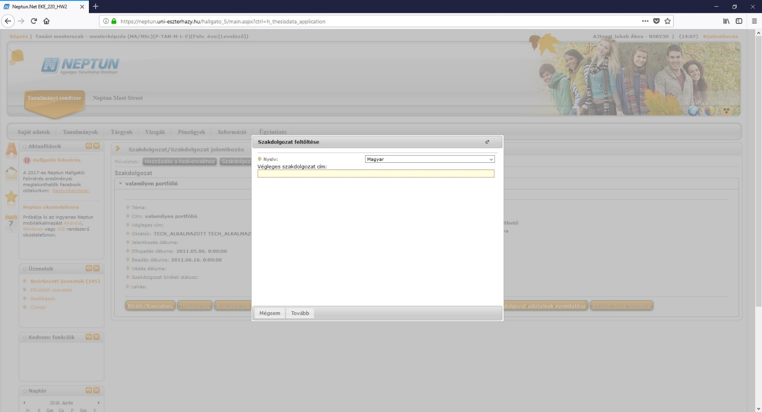

Click on „uploading file” which shall contain all of the abovementioned parts of the thesis. Then click on „Save”.

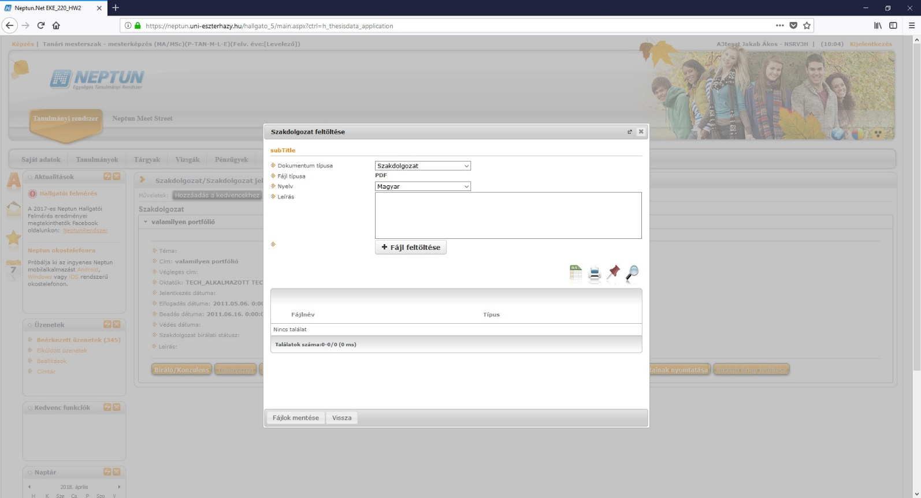

If the thesis is obliged to contain for example an online programme, database, webdesign, movie, piece of art, etc.), then it shall be uploaded as a zip file!
In this case, the zip file shall be named as follows: neptun code of the student in capitals, underscore, year of submission, dot and extension. The extension has to be zip and it shall not be in capitals! (eg.: ABCDEF_2020.zip)
At the same time, the full text (pdf) shall be uploaded to Neptun.
The size of the file can be maximum 100 Mbyte. If the file is larger than 100 Mbyte the student has to submit it on a USB stick to the Registrar’s Office.

How to check successful uploading
Under „uploading thesis”, click on „view” and you are able to check the status of your thesis.

Thesis encryption
According to section 54 (3) of Studies and Examinations Code, students can submit a request of encrypting the thesis: The author or an authorized organization can ask the supervisor to respect confidentiality. If the supervisor asks the encryption, the thesis shall only be handed to the reviewer and the final exam committee. Encryption requests shall be submitted on Neptun (Administration/Requests). Post-encryption is not possible.
Submission of thesis
After the uploading process, the printed version of the thesis shall be submitted to the Registrar’s Office. Only uploaded theses can be submitted in the Office! As far as form and content are concerned, the online and the printed version of the thesis shall be identical!

If you experience any errors, please send an e-mail to nagy-macsay.judit@uni-eszterhazy.hu

Checking the review of thesis
One week before the defence, students can download the review sheet of the thesis (NeptunThesis”+” signfind out morenext to the name of the supervisor, you can download your review sheet).
.

Consulting thesis evaluation
One week before defense, students may download the completed thesis evaluation from Neptun. In the thesis section, click on “+” and click „further” where you can download the evaluation if you click “+” next to the name of your supervisor and the evaluator.

